# **Mississippi / Vendor Challenge Doc**

## The Task

Create a working prototype for the following user story:

*“As a caseworker or parent, I would like to search for child care providers in my vicinity so that I can choose the best provider for a child.”*

The submission of the working prototype serves as a sample task that the State believes is representative of the type of task orders that may be issued against the agile vendor pool in the future.

The prototype would be an alternative to this form: <https://www.apps.mdhs.ms.gov/ccis/DECCDProviderSearch.aspx>.

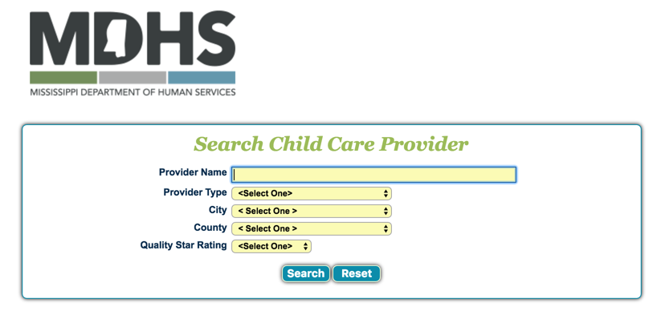

We do not require feature parity with the above form.

We would like to see your solution based on the data provided at URL (*CSV-FILE-GOES-HERE*). The dataset is defined in LINK (DATASET-DEFINITION-GOES HERE).

Caseworkers who have had on-the-ground experience with the existing tool will be available from DATE to DATE for interviews and questions. E-mail [name@domain.com](mailto:name@domain.com) to RSVP.

### Submission requirements:

* Prototype must be hosted at a publicly-available URL.
* Use git to track any changes made in constructing the prototype, such as commits, comments, etc. Submit a git bundle of the entire repository, with all branches, including history.
* Assemble a multidisciplinary and collaborative team that includes, at a minimum, three of the labor categories as identified in the [18F Agile Labor Categories](https://pages.18f.gov/agile-labor-categories/).
* Include a README.md file in the root directory of the repository that includes any instructions needed to get it up and running.
* Don't minify any of the JavaScript or CSS used in the application.
* Include additional data as needed for a better solution that meets user needs.

## 

## What we are looking for

The Vendor’s work should follow the principles and practices outlined in [the U.S. Digital Services playbook](https://playbook.cio.gov/). In addition to specific plays from the playbook called out in this document, vendors are encouraged to incorporate as many plays as possible in their submission. When using a play from the handbook, please call it out in the artifacts and documentation that are submitted.

Vendors are required to submit a working prototype at a publicly-available URL.

Vendors should exercise the reasonable judgment of a product owner in making decisions about how you address the design requests. When a feature is unclear, describe the design decisions and assumptions made, with corresponding rationale.

In addition, we will be looking for the following in the project:

### Project Details

**Documentation:** Write a brief description of the project, no greater than 150 words.

In addition, list out all artifacts used to create the prototype, including research findings, user stories, frameworks or libraries used and why, and functional descriptions for all components of the prototype. Place all documentation in the README.md file (See — <https://playbook.cio.gov/#play13>).

**Criteria for evaluation** — Answers should be **Excellent / Acceptable / Unacceptable / N/A**

* The documentation should be clearly written and well organized
* The documentation should cover all artifacts and processes used to create the prototype
* The documentation should offer users a mechanism to report bugs and issues with it

**Team Structure:** Assemble a multidisciplinary and collaborative team that includes, at a minimum, three of the labor categories as identified in the [18F Agile Labor Categories](https://pages.18f.gov/agile-labor-categories/). These labor categories are provided in Section 8 of the RFP. In addition, please provide the hourly rate and the total number of hours for each of the three labor categories proposed for completing this prototype.

Vendors are not restricted to only using the labor categories they selected for the prototype when executing subsequent letters of configuration.

**Criteria for evaluation** — Answers should be **Excellent / Acceptable / Unacceptable / N/A**

* Document the team structure, along with roles, responsibilities and corresponding 18F Labor Categories.
* Assign a leader to the team and give that person the authority and responsibility for delivering the project. That person is accountable for the quality of the prototype submitted (see <https://playbook.cio.gov/#play6>).

### Research and discovery

Initiate a research phase to explore the [existing tool](https://www.apps.mdhs.ms.gov/ccis/DECCDProviderSearch.aspx) and pinpoint the needs of the people who will use the service, and the ways the service will fit into their lives. Document the process and findings. (see: <https://playbook.cio.gov/#play1>)

**Criteria for evaluation —** *Answers should be* ***Excellent / Acceptable / Unacceptable / N/A***

* Spend time with current and prospective users of the service.
* Use qualitative and quantitative research methods to determine people’s goals, needs, and behaviors; be thoughtful about the time spent.
* Test prototypes of solutions with prospective users you do not have a current direct relationship with (e.g. friends, coworkers, family, etc). Explain how you found them in the documentation.
* Document the findings about user goals, needs, behaviors, and preferences.
* Create a prioritized list of tasks the user is trying to accomplish.

### Design

Initiate a research phase to explore and pinpoint the needs of the people who will use the service.

**Criteria for evaluation —** *Answers should be* **Excellent / Acceptable / Unacceptable / N/A**

* Use a simple and flexible design style guide for the service (e.g. [U.S. Web Design Standards](https://standards.usa.gov/)).
* Give users clear information about where they are in each step of the process.
* Follow accessibility best practices to ensure all people can use the service.
* Use language that is familiar to the user and easy to understand.
* Use language and design consistently throughout the service, including online and offline touch points.

### Prototype (Technical Test)

**Criteria for evaluation —** *Answers should be* **Excellent / Acceptable / Unacceptable / N/A**

* Create a prototype that works on multiple devices (e.g. desktops, tablets, smart phones) using a responsive design.
* Use modern and open-source technologies, regardless of architectural layer (frontend, backend, etc.). Prototype and underlying platforms used to create and run the prototype are openly licensed and free of charge.
* Deploy the prototype on an Infrastructure as a Service (IaaS) or Platform as Service (PaaS) provider with
  + the ability to easily manage the configuration.
  + the ability to monitor the deployment and be alerted on issues.
* Develop automated unit tests for the code with adequate test coverage.
* Use a continuous integration system to automate the running of tests and to continuously deploy code to the IaaS or PaaS provider.
* Provide sufficient documentation to install and run the prototype on another target.